

**COMPSOFT TECHNOLOGIES**

****

INTERNSHIP

REPORT

ON

“Quora for engineering students”

#### Bachelor of Engineering

#### In

#### Computer Science and Engineering

#### Submitted by: CHAITHRA SHREE A V (1JV19CS006)

#### NAVYA S K (1JV19CS016)

#### PRIYA N (1JV19CS019)

#### janavikas_logo.jpg

**JNANA VIKAS INSTITIUTE OF TECHNOLOGY**

#### 2022

## ABOUT THE COMPANY

We are a digital service provider that aims to provide software, designing and marketing solutions to individuals and businesses, we believe that service and quality is the key to success

We provide all kinds of technological and designing solutions from Billing Software to Web Designs or any custom demand that you may have. Experience the service like none other!

Some of our services include:

Development - We develop responsive, functional and super-fast websites.

We keep User Experience in mind while creating websites. A website should load quickly and should be accessible even on a small view-port and slow internet connection.

Mobile Application - We offer a wide range of professional Android, iOS & Hybrid app development services for our global clients, from a start up to a large enterprise.

Design - We offer professional Graphic design, Brochure design & Logo design. We are experts in crafting visual content to convey the right message to the customers.

Consultancy - We are here to provide you with expert advice on your design and development requirement.

Videos - We create a polished professional video that impresses your audience.

**TABLE OF CONTENTS**

Table of contents i

[Overview of the Project 1](#_TOC_250006)

[About 2](#_TOC_250005)

Why QES [3](#_TOC_250004)

[Tools Used 4](#_TOC_250003)

[Implementation 5](#_TOC_250002)

[Snapshots 21](#_TOC_250001)

[Bibliography 25](#_TOC_250000)

## OVERVIEW OF THE PROJECT

## Project Name: Quora for Engineering Students

**Team Members:** CHAITHRA SHREE A V (1JV19CS006)

**NAVYA S K (1JV19CS016)**

**PRIYA N (1JV19CS019)**

## This project is based on Web Development And its Applications. The main objective of this project is to learn the implementation of HTML, CSS and JavaScript. The basic webpage of this project is created using HTML and styling of the webpage is done using CSS.

## This webpage is about one of the page that deals with Quora for Engineering Students.

## ABOUT QES

## This QES website will provide complete question with answer in the form of multiple choices which helps engineering students. It meets all the requirements for students with viva questions, competitive questions, interview questions and also aptitude questions and many more for the students for better future.

## Why LG phones are discontinued

# TOOLS USED

### Software Requirements

* Visual Studio Code 2019.
* Google Chrome or Microsoft Edge of latest version.
* Front End: HTML, CSS, JS (optional)
* Linux 7.1 or Windows XP/7/8/10 OS or Mac OS

### Hardware Requirements

* Pentium 200-MHz computer with a minimum of 64 MB of RAM (128 MB of RAM recommended).
* Monitor with a refresh rate of at least 40Hz for a smooth GUI experience (optional).

# IMPLEMENTATION

# Source Code (PROJECT01.HTML):

<!DOCTYPE html>

<html>

    <head>

        <meta name="viewport" content="width=device-width, initial-scale=1.0">

        <title>my project</title>

        <link rel="stylesheet" href="style01.css">

        <link rel="stylesheet" href="sign.html">

        <link rel="stylesheet" href="cs.html">

       <link rel="stylesheet" href="login.html">

       <link rel="stylesheet" href="cv.html">

       <link rel="stylesheet" href="about.html">

        <link rel="stylesheet" href="contact.html">

        <link rel="stylesheet" href="https://cdn.jsdelivr.net/npm/@fortawesome/fontawesome-free@5.15.4/css/fontawesome.min.css">

     <link rel="stylesheet" href="https://cdnjs.cloudflare.com/ajax/libs/font-awesome/4.7.0/css/font-awesome.min.css">

    </head>

    <body>

        <section class="header">

            <nav>

                <a href="project01.html"><img src="logo.png"></a>

                <div class="nav-links">

                <ul>

                    <li> <a href="">home</a></li>

                    <li> <a href="about.html">about</a></li>

                    <li> <a href="contact.html">contact</a></li>

                    <li> <a href="contact.html">help</a></li>

                    <li> <a href="sign.html">signin</a></li>

                    <li> <a href="login.html">login</a></li>

                </ul></div>

            </nav>

            <div class="text-box">

                <h1> where work happens</h1>

                <p>answering questions is one of the biggest easiest thing.

                    <br> ask a question and you will be sure to find answer</p>

                <a href="" class="hero-btn">learn more</a>

                <a href="" class="hero-btn">hit and grab questions</a>

                        </div>

        </section><br><br>

        <div class="container">

            <form action="https://www.google.com/" class="search-bar">

                <input type="text" placeholder="search anything" name="q">

                <button type="submit"><img src="search.png"></button>

            </form>

        </div>

<section class="project">

    <h1>...Landing questions & answers for you </h1><br><br><br>

    <a href="" class="hero-btn"><table border="3" width="100%" bgcolor="pink">

        <tr>

            <td width="20%"><a href="cv.html">civil engineering</a></td>

            <td width="20%"><a href="cs.html">computer science engineering</a></td>

            <td width="20%"><a href="ec.html">ECE engineering</a></td>

            <td width="20%"><a href="physics.html">physics engineering</a></td>

            <td width="20%"><a href="cs.html">chemistry engineering</a></td>

        </tr>

    </table></a>

</section>

<section>

<div class="row">

    <div class="project-col">

        <h2>awesome option</h2>

        <p>we offer range of tarining pavkages in range of subject</p>

        <a href"" class="hero-btn">read more</a>

    </div>

    <div class="project-col">

        <h2>popular questions</h2>

        <p>we offer range of tarining pavkages in range of subject</p>

        <a href"" class="hero-btn">read more</a>

    </div>

    <div class="project-col">

        <h2>tutorial videos</h2>

        <p>we offer range of tarining pavkages in range of subject</p>

        <a href"" class="hero-btn">read more</a>

    </div>

</div></section>

<div class="row">

    <h2>courses available</h2>

<div class="project-col">

    <img src="cv.jpg">

    <div class="layer"><h3>civil engineering</h3></div>

</div>

<div class="project-col">

    <img src="css.jpg">

    <div class="layer" href="cs.html"><h3>computer science engineering</h3></div>

</div>

<div class="project-col">

    <img src="ec.jpg">

    <div class="layer"><h3>electrical engineering</h3></div>

</div>

<div class="project-col">

    <img src="phy.jpg">

    <div class="layer"><h3>physics</h3></div>

</div>

<div class="project-col">

    <img src="chemistry.png">

    <div class="layer"><h3>chemistry</h3></div>

</div>

</div>

</section>

<section class="facilities">

    <h1>our facilities</h1>

    <p>play.learn.educate</p>

<div class="row">

    <div class="facilities-col">

        <img src="training1.jpg">

        <h3>trainings</h3>

    </div>

    <div class="facilities-col">

        <img src="internship.jpg">

        <h3>internships</h3>

    </div>

    <div class="facilities-col">

        <img src="job.jpg">

        <h3>placements</h3>

    </div>

</div>

</section>

<section class="comment">

    <h1>know what people say</h1>

    <p>...comments...</p>

    <div class="row">

        <div class="comment-col">

        <img src="cgirl.jpg">

        <div><p>“I’m so impressed by your dedication to learning. I know it wasn’t easy when that technology solution you presented didn’t work out. I’m amazed that you managed to distill feedback from all those stakeholders and find a new, viable solution that everyone loves.”</p>

            <h3>pinky</h3>

        </div>

    </div>

    <div class="comment-col">

        <img src="cboy.jpg">

        <div><p>I believe I would be lost if you weren't in the office, and I'm happy to say tha

            t I don't ev

            en know if I'm right. Thank you for always being there</p><h3>justin</h3>

        </div>

    </div>

    <div class="comment-col ">

        <img src="cgirl2.webp">

        <div><p>information about reactions to a product, a person's performance of a task, etc.

             which is used as

            a basis for improvement.</p><h3>christina</h3>

        </div>

    </div>

</section>

<section class="cta">

<h1> enroll for our various online site anywhere from the world</h1>

<a href"contact.html" class="hero-btn">contact us</a>

</section>

<section class="footer">

    <h3>about us</h3>

    <p>iconic is a digital and reader website and app with a collection of over 40,000 questions and answers. Students can search for questions and also be assigned questions and answer.

      <br>  Free accounts are available to use during the every day.<br>

        <br>There is also a large number of read questions and answers, which are excellent for students to answer them aand gain knowledge.

       <br> Iconic also includes an educational video, tutorial videos, magazines, and options to track students</p>

<div class="icons">

    <i class="fa fa-facebook"></i>

    <i class="fa fa-twitter"></i>

    <i class="fa fa-instagram"></i>

    <i class="fa fa-linkedin"></i>

</div>

    </section>

    </body>

</html>

# IMPLEMENTATION

# Source Code (STYLE01.CSS+P1.JS(if used)):

\*{

    margin: 0;

    padding: 0;

}

.header {

    min-height: 100vh;

    width: 100%;

    background-image: linear-gradient(rgba(4,9,30,0.7),rgba(4,9,30,0.7)), url(q&a.jpeg)

    ;

    background-position: center;

    background-size: cover;

    background-position: relative;

}

nav{

    display: flex;

    padding: 2% 6%;

    justify-content: space-between;

    align-items: center;

}

nav img{

    width: 150px;

}

.nav-links{

    flex: 1;

    text-align: right;

}

.nav-links ul li{

    list-style: none;

    display: inline-block;

    padding:8px 12px;

    position: relative;

}

.nav-links ul li a{

    color: #fff;

    text-decoration: none;

    font-size: 13px;

}

.nav-links ul li::after{

    content: '';

    width: 0%;

    height: 2px;

    background: #f44336;

    display:block;

    margin: auto;

    transition: 0.5s;

}

.nav-links ul li:hover::after{

    width: 100%;

}

.text-box{

    width: 90%;

    color: #fff;

    position: absolute;

    top: 50%;

    left: 50%;

    transform: translate(-50%,-50%);

    text-align: center;

}

.text-box h1{

    font-size: 62px;

}

.text-box p{

    margin: 10px 0 40px;

    font-size: 14px;

    color: #fff;

}

.hero-btn{

    display: inline-block;

    text-decoration: none;

    color: #fff;

    border: 1px solid #fff;

    padding: 12px 34px;

    font-size: 13px;

    background: transparent;

    position: relative;

    cursor: pointer;

}

.hero-btn:hover{

    border: 1px solid #f44336;

    background: #f44336;

    transition: 1s;

}

nav .fa{

    display: none;

}

.project {

    width: 80%;

    margin: auto;

    text-align: center;

    padding-top: 100px;

}

h1{

    font-size: 36px;

    font-weight: 600;

}

p{

    color: #777;

    font-size: 14px;

    font-weight: 300;

    line-height: 22px;

    padding:10px;

}

.row{

    margin-top: 5%;

    display: flex;

    justify-content: space-between;

}

.project-col{

    flex-basis: 31%;

    background: #fff3f3;

    background: radius 10px;

    margin-bottom: 5%;

    padding: 20px 12px;

    box-sizing: border-box;

}

h2{

    text-align: center;

    font-weight: 1000;

    margin: 10px;

}

.project-col:hover{

    box-shadow: 0 0 20px 0px rgba(0,0,0,0.2);

}

.project-col{

    flex-basis: 32%;

    border-radius: 10px;

    margin-bottom: 30px;

    position: relative;

    overflow : hidden;

}

.project-col img{

width: 100%;

display: block;}

.layer{

    background: transparent;

    height: 100%;

    width: 100%;

    position: absolute;

    top: 0%;

    left: 0%; transition: 0.5s;

}

.layer:hover{

    background: rgba(7, 118, 182, 0.7);

}

.layer h3{

    width: 100%;

    font-weight: 500;

    color: #fff;

    font-size: 26px;

    bottom: 0;

    left: 50%;

    transform: translate(-50%);

    position: absolute;

    opacity: 0;

    transition: 0.5s;

}

.layer:hover h3{

    bottom: 49%;

    opacity: 1;

}

.comment{

    width: 80%;

    margin: auto;

    padding-top: 100px;

    text-align: center;

}

.comment-col{

    flex-basis: 44%;

    border-radius: 10px;

    margin-bottom: 5%;

    text-align: left;

    background: #fff3f3;

    padding: 25px;

    cursor: pointer;

    display : flex;

}

.comment-col img{

    height: 40px;

    margin-left: 5px;

    margin-right: 30px;

    border-radius: 50%;

}

.comment-col p{ padding: 0%;}

.comment-col h3{

    margin-top: 15px;

    text-align: left;

}

.cta{

    margin: 100px auto;

    width: 80%;

    background-image: linear-gradient(rgba(0,0,0,0.7),rgba(0,0,0,0.7)), url(contact.png);

background-position: center;

background-size: cover;

border-radius: 10px;

text-align: center;

padding: 100px 0;

}

.cta h1{

    color: #fff;

    margin-bottom: 40px;

    padding: 0;

}

.footer{

    background-image: linear-gradient(rgba(0,0,0,0.7),rgba(0,0,0,0.7)), url(aboutus01.jpg);

    width: 100%;

    text-align: center;

    font-family: 'Times New Roman', Times, serif;

    padding: 30px 0;

}

.footer h3{

    margin-bottom: 25px;

    margin-top: 20px;

    font-weight: 600;

}

.facilities{

    width: 80%;

    margin: auto;

    text-align: center;

    padding-top: 100px;

}

.facilities-col{

    flex-basis: 31%;

    border-radius: 10px;

    margin-bottom: 5%;

    text-align: center;

}

.facilities-col img{

    width: 100%;

    border-radius: 10px;

}

.container{

    display: flex;

    align-items: center;

    justify-content: center;

}

.search-bar{

    width: 100%;

    max-width: 700px;

    background:rgb(131, 187, 173);

    display: flex;

    align-items: center;

    border-radius: 60px;

    padding: 10px 20px;

    backdrop-filter: blur(4px) saturate(108%);

}

.search-bar input{

    background: transparent;

    flex: 3;

    border: 0;

    outline: none;

    padding: 24px 20px;

    font-size: 20px;

    color: #cac7ff;

}

.search-bar button img{

    width: 25px;

}

.search-bar button{

    border: 0;

    border-radius: 50%;

    width: 60px;

    height: 60px;

    background: rgb(131, 187, 173);

    cursor: pointer;

}

# IMPLEMENTATION

# Snapshots :

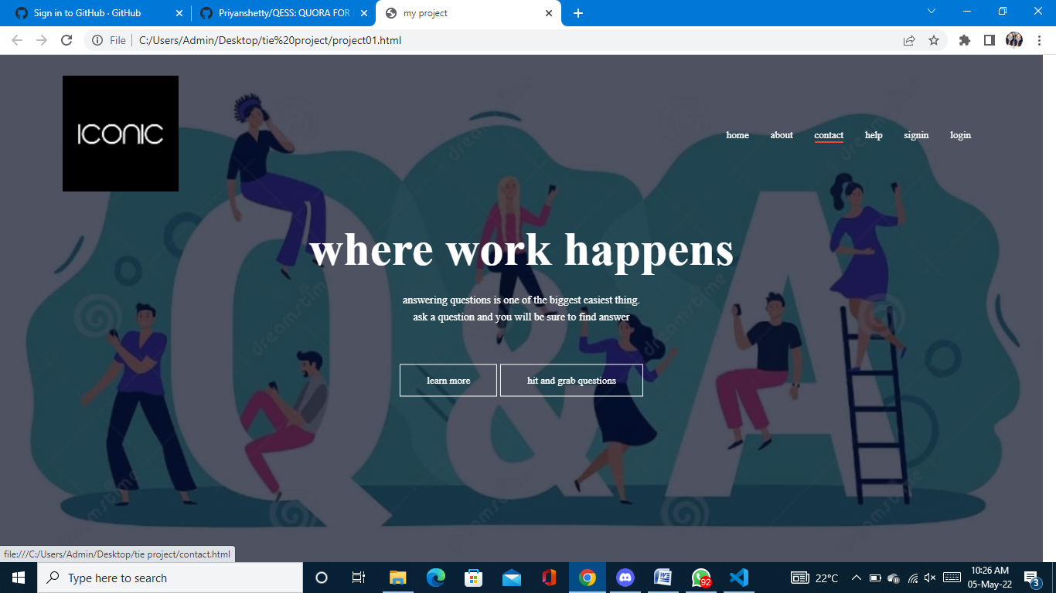

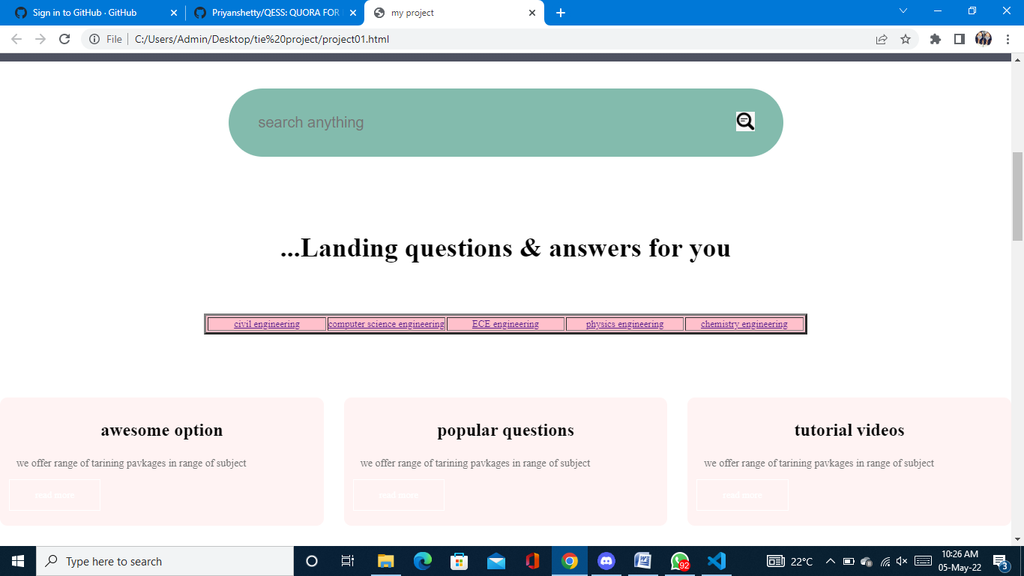

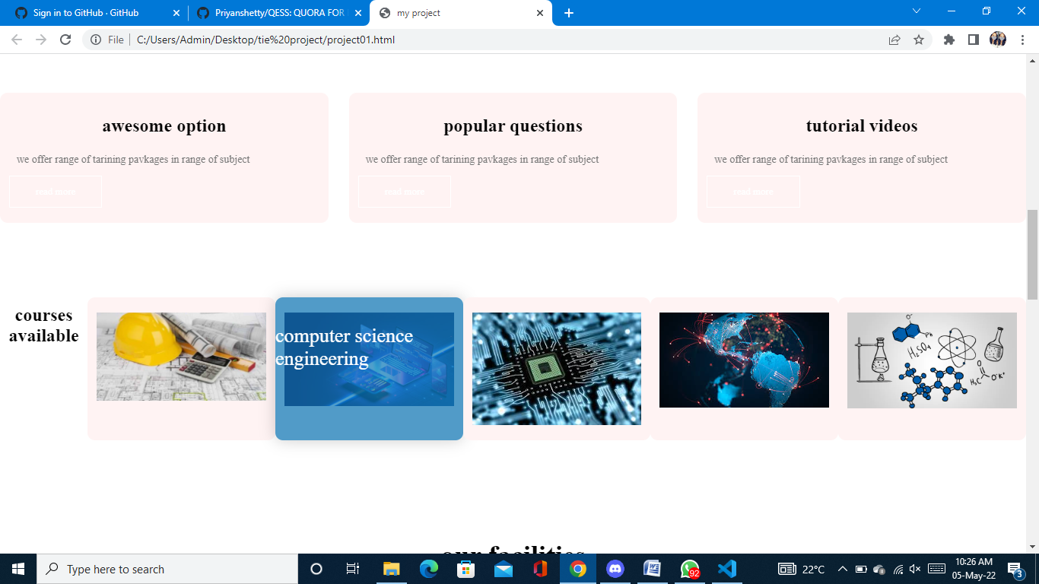

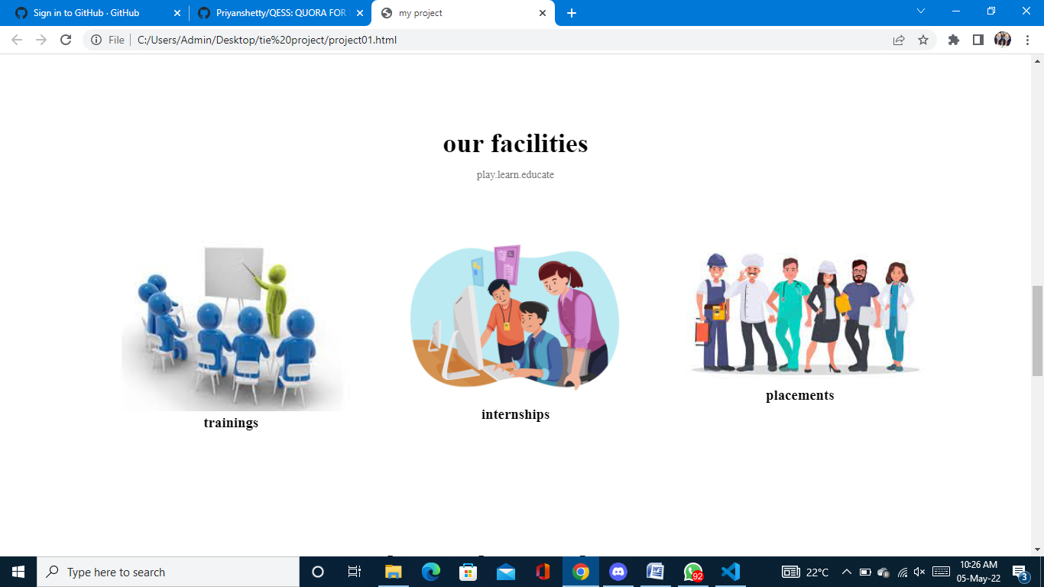

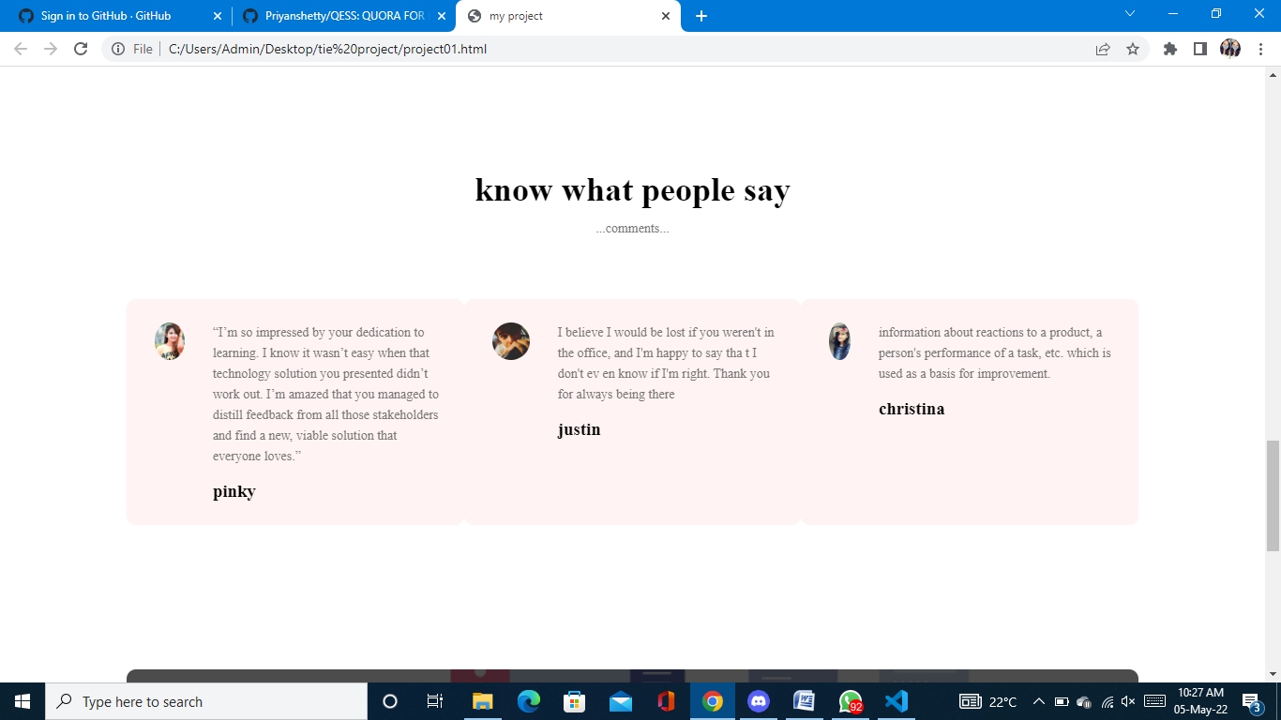

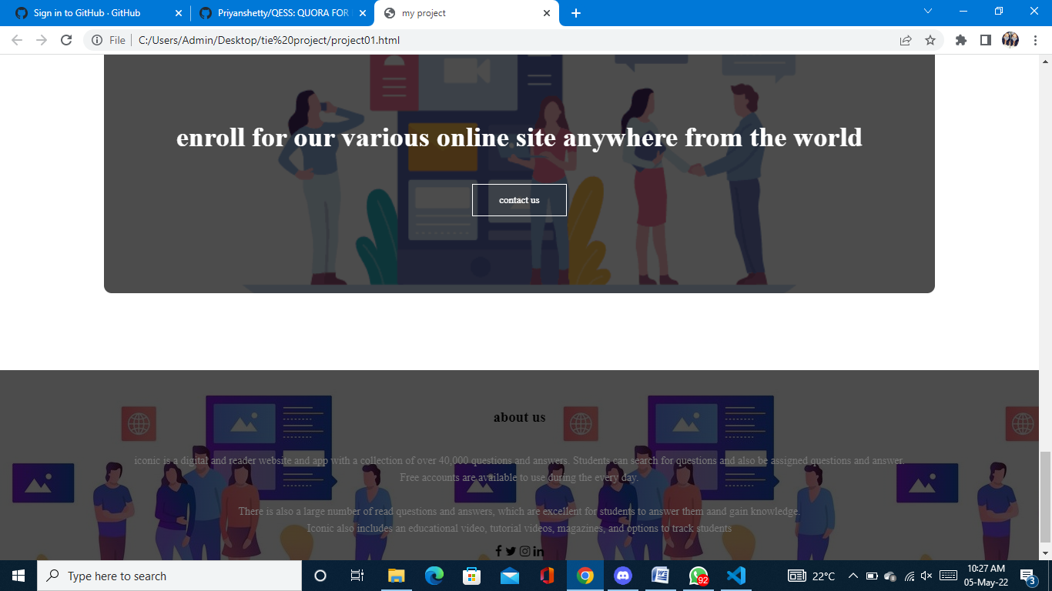

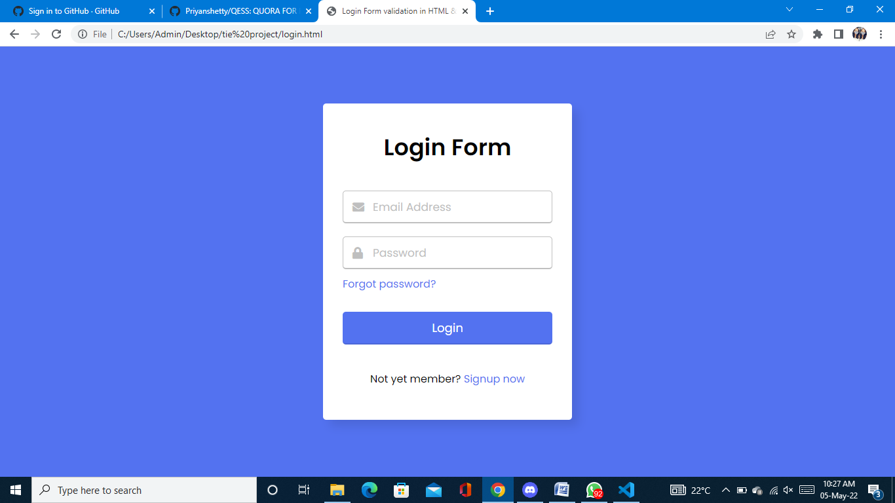

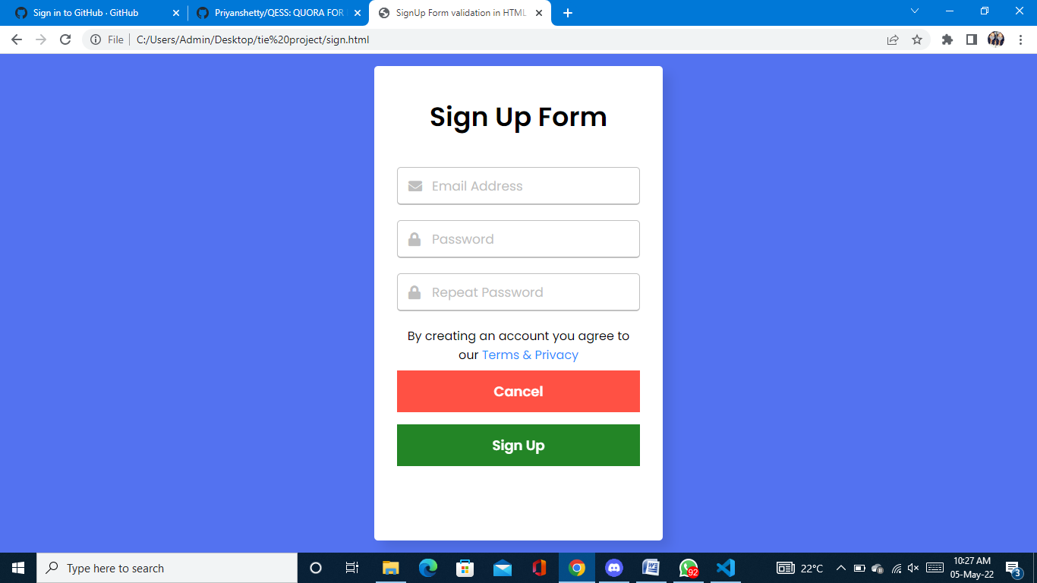

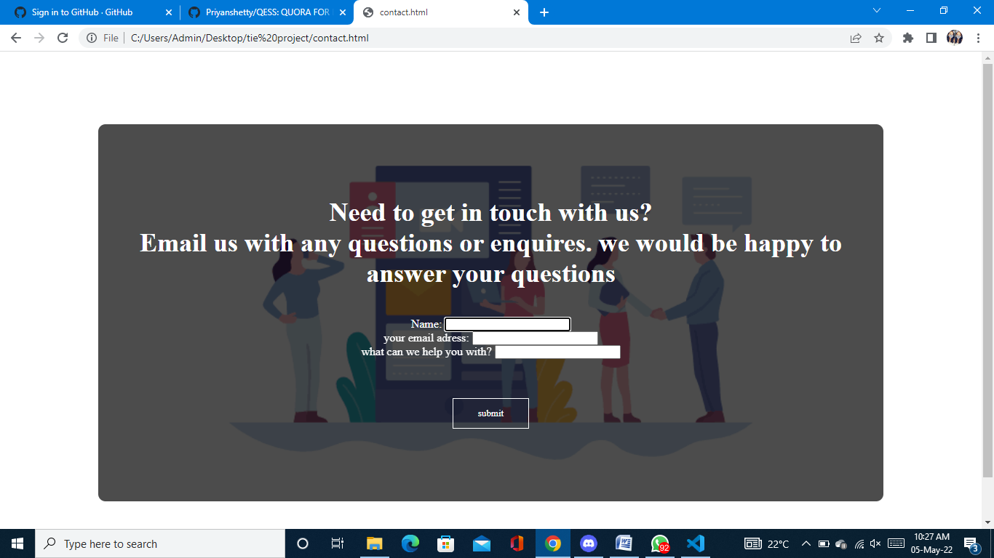

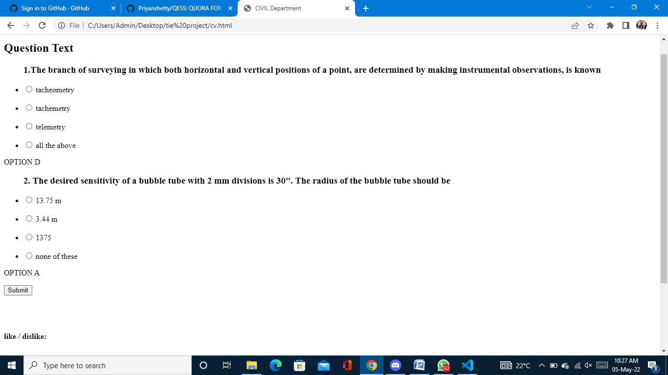

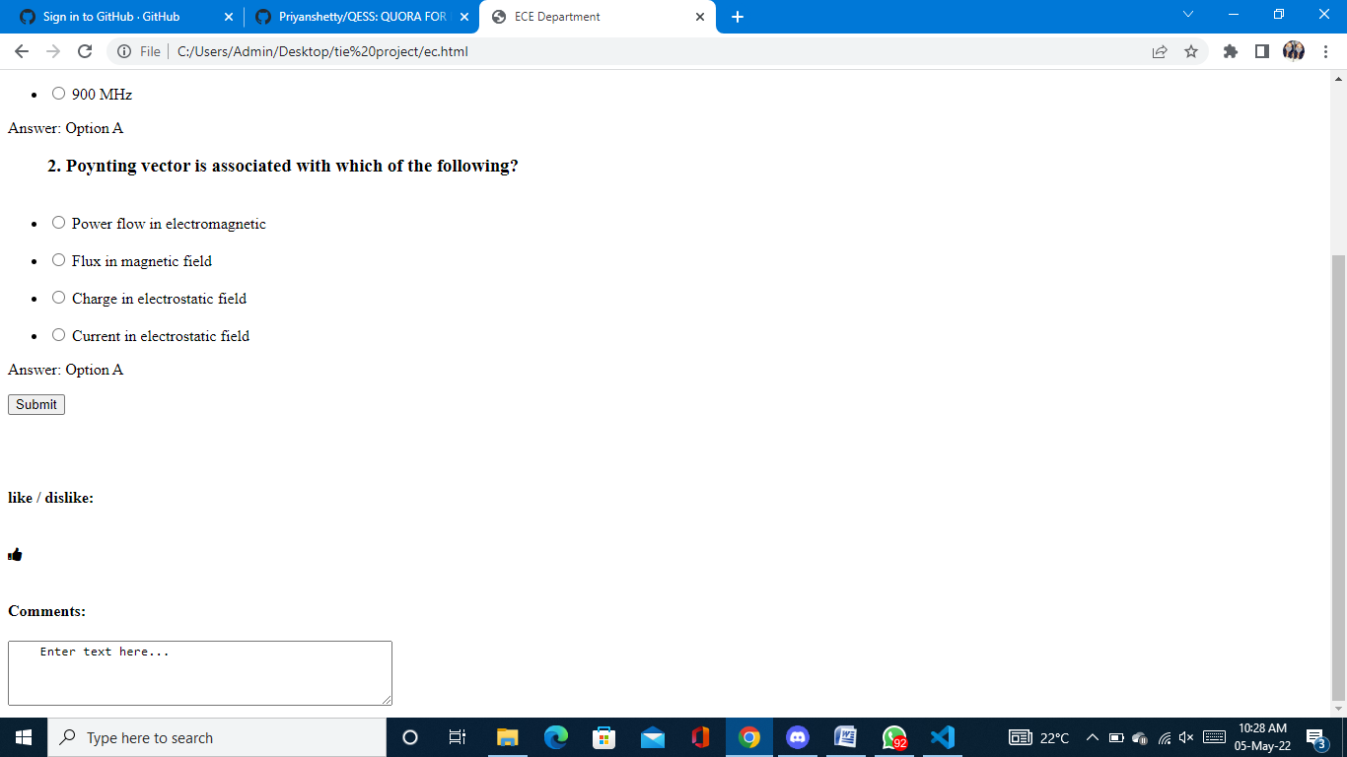

**BIBLIOGRAPHY**

* https://[www.w3schools.com](http://www.w3schools.com/)
* https://[www.geeksforgeeks.org](http://www.geeksforgeeks.org/)
* https://quora.com
* https://freefrontend.com

## About my TEAM

<include your team mates’ names and the role played by the teammates>

1. CHAITHRA SHREE A V

Java script and css code implementation

Backend design about the quora for engineering students

Report

1. PRIYA N

Java script and css code implementation

Required images and sources are provided

Report

1. NAVYA S K

Frontend design

Html+Css

Report